[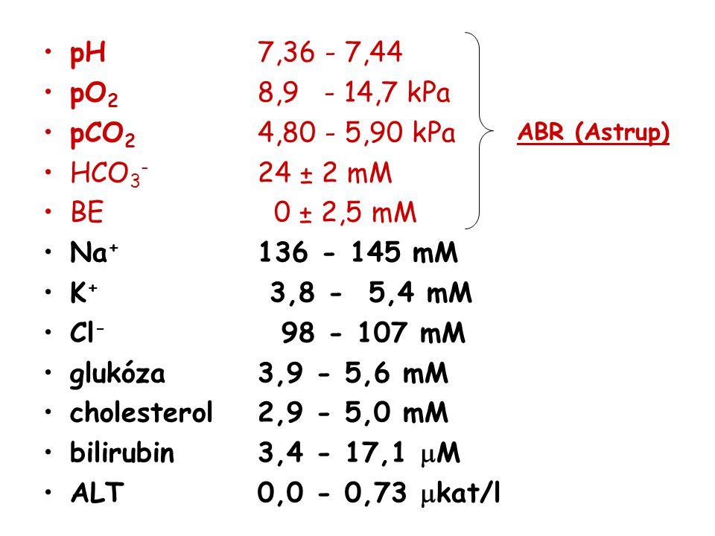](https://www.google.com/url?sa=i&url=https%3A%2F%2Fslideplayer.cz%2Fslide%2F2293082%2F&psig=AOvVaw2E6ZSb5xmX7k4etVGPfrEf&ust=1583864343960000&source=images&cd=vfe&ved=0CAIQjRxqFwoTCODquc6AjugCFQAAAAAdAAAAABAE)

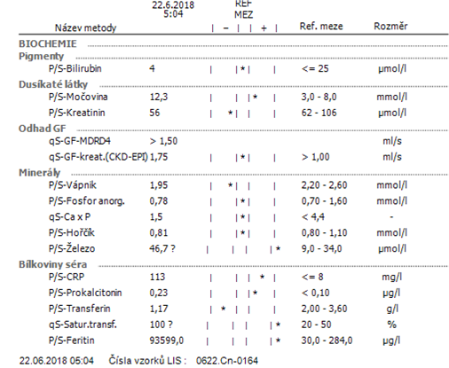

[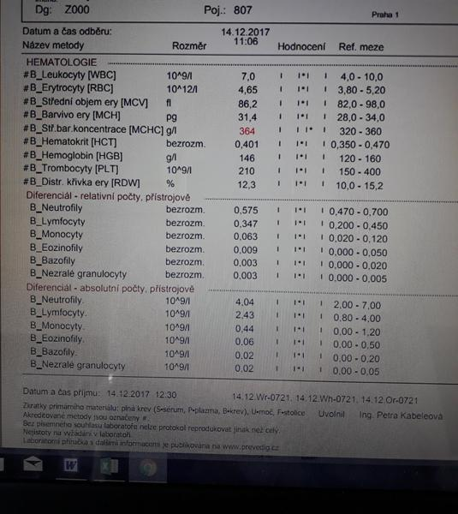](https://www.google.com/url?sa=i&url=https%3A%2F%2Fwww.modrykonik.cz%2Fforum%2Fme-zdravi%2Fkrevni-obraz-mchc-mam-364-2%2F&psig=AOvVaw1LKPiPBpuRTYFtt4z3bIHB&ust=1583864441628000&source=images&cd=vfe&ved=0CAIQjRxqFwoTCND_iP2AjugCFQAAAAAdAAAAABAP)

[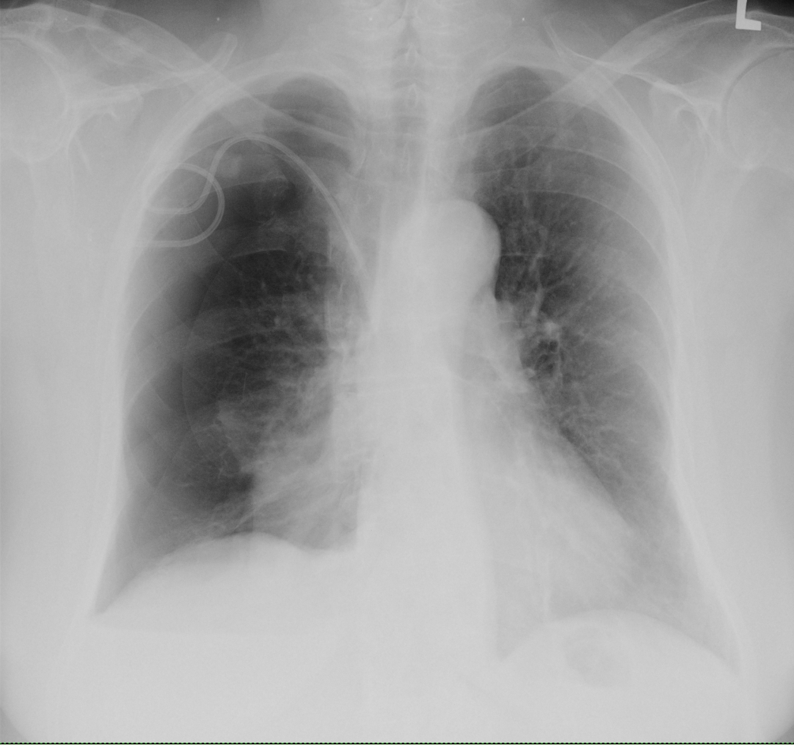](https://www.google.com/url?sa=i&url=https%3A%2F%2Fwww.wikiskripta.eu%2Fw%2FPneumotorax&psig=AOvVaw34He4h7yZKhj-0hwcKNnL-&ust=1583864585065000&source=images&cd=vfe&ved=0CAIQjRxqFwoTCPjLtcGBjugCFQAAAAAdAAAAABAE)

<https://www.akutne.cz/res/publikace/p-e-o-pacienta-v-sepsi-kavalcov-j.pdf>