HEALTH

This Simple Finger Test Could Reveal Signs of Lung Cancer and Other Health Conditions
Asimple finger test which you can do yourself could reveal the presence of an underlying health condition, including lung cancer.
The so-called Schamroth window test helps to identify a rare type of deformity in the fingers and fingernails—known as "digital clubbing" or "finger clubbing"—which people with some heart or lung problems exhibit.
According to Cancer Research U.K., finger clubbing occurs in stages. First, the base of the nail (nail bed) softens and the skin next to the nail bed becomes shiny.
Second, the nails begin to curve more than normal when looked at from the side. This is known as "Scarmouth's sign." Lastly, the ends of the fingers may get larger—which is often referred to as "drumstick fingers."
Scientists think that clubbing is the result of fluid collecting in the soft tissue at the ends of the fingers. This is caused by unusually large amounts of blood flowing into the area. However, the mechanisms behind this are not well understood.
Finger clubbing occurs in around 35 percent of people with non-small cell lung cancer but only around 4 percent of people with small cell lung cancer. It is also seen in a type of cancer known as mesothelioma, which commonly affects the lining of the lungs and chest wall.
It is important to note that having finger clubbing is not a definitive sign of cancer. It can be caused by several diseases of the lung, such as cystic fibrosis, pulmonary fibrosis, bronchiectasis or asbestosis, as well certain heart defects, liver disease, or Crohn's disease.
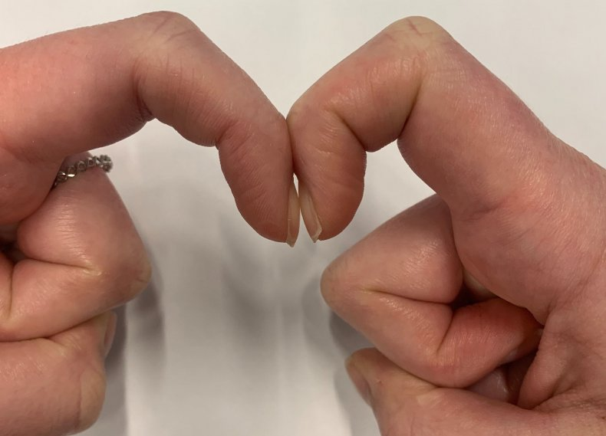
A demonstration of the Schamroth window test with the diamond-shaped gap visible.NEWSWEEK
If you suspect you have finger clubbing, the Schamroth window test is an easy way to check, although it should only be used as a guide and is not a replacement for seeing a real doctor.
"The test is used by medical professionals as a partial method of confirming conditions, but you can also do the test yourself—and it only takes a few seconds," Emma Norton from healthcare company Bupa U.K. told the Huffington Post.
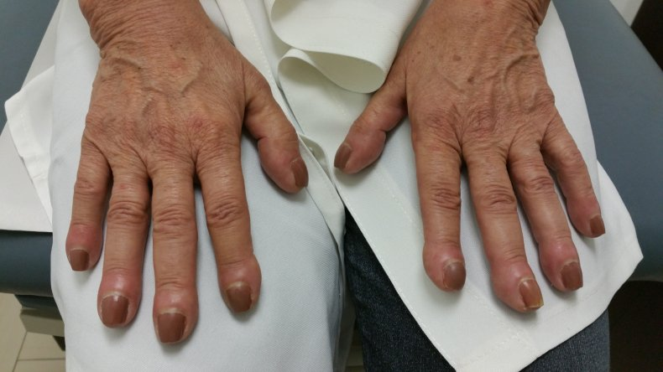
Finger clubbing, also known as digital clubbing, is a deformity of the finger or toe nails associated with a number of diseases, mostly of the heart and lungs. Clubbing for no obvious reason can also occur, but is rare.ISTOCK
To take the test, put your hands out in front of your eyes and place your index fingers together with the nails touching face to face with each other. Normally, you should see a diamond-shaped space between the two nail bed angles.
If you can't see this space however, your fingers could be clubbed—and this in turn may be a sign of an underlying condition. In this case, Norton recommends visiting a doctor as soon as possible for further examination.

