[[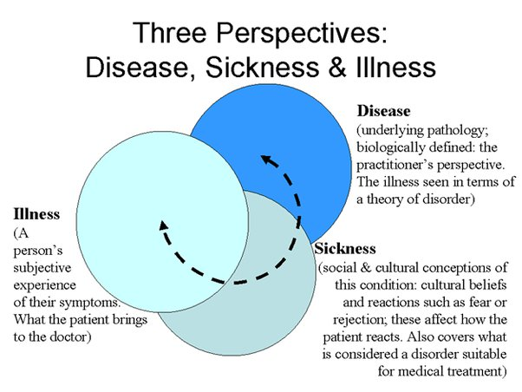](https://www.google.com/url?sa=i&url=https%3A%2F%2Fwww.quora.com%2FWhat-is-the-difference-between-illness-disorder-disease-and-sickness&psig=AOvVaw3L4Z7AUl60BpY5Ccor_PkW&ust=1709030063861000&source=images&cd=vfe&opi=89978449&ved=0CBIQjRxqFwoTCLDVuLPnyIQDFQAAAAAdAAAAABAE)](https://www.google.com/url?sa=i&url=https%3A%2F%2Fwww.quora.com%2FWhat-is-the-difference-between-illness-disorder-disease-and-sickness&psig=AOvVaw3L4Z7AUl60BpY5Ccor_PkW&ust=1709030063861000&source=images&cd=vfe&opi=89978449&ved=0CBIQjRxqFwoTCLDVuLPnyIQDFQAAAAAdAAAAABAE)

[](https://www.google.com/url?sa=i&url=https%3A%2F%2Fwww.quora.com%2FWhat-is-the-difference-between-illness-disorder-disease-and-sickness&psig=AOvVaw3L4Z7AUl60BpY5Ccor_PkW&ust=1709030063861000&source=images&cd=vfe&opi=89978449&ved=0CBIQjRxqFwoTCLDVuLPnyIQDFQAAAAAdAAAAABAE)